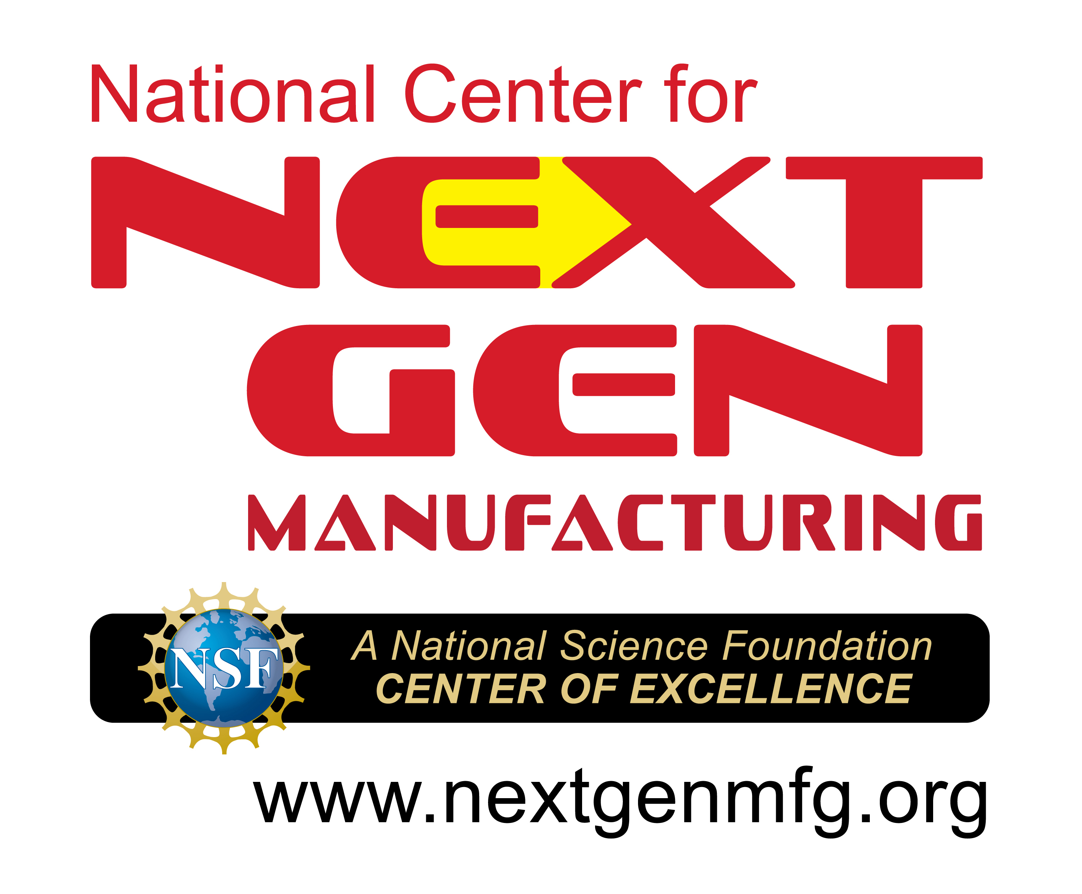
SUMMER TEACHERS’
WORKSHOP

Virtual Workshop
June 22 - 23 & 26 - 27, 2023

Technology & Professional Skills Training
for
Classroom Implementation
FEATURING
Technology Topics & Skills
Introduction to Manufacturing ~ 3D Printing/Additive Manufacturing
SolidWorks 3D Modeling ~ Programming using Drone Kits
Teambuilding Topics & Skills
Development & Preservation of Effective Teams ~ Understanding Behavioral Diversity using DISC
Professional & Interpersonal Skills ~ Emotional Intelligence
Access to a one-year online educational version of SolidWorks CAD Software
Participants will be sent a micro:bit kit and mini drone kit
Participants will be eligible to receive up to $750 in stipends

For additional information email: wrobicheau@commnet.edu

2023 Summer Teachers’ Workshop

General Information
The Connecticut College of Technology’s National Center for Next Generation Manufacturing, a National Science Foundation Center of Excellence, will present the 2023 Summer Teachers’ Workshop. This program will be held through an online platform.

This exciting four-day workshop provides the opportunity for you to connect with your peers from across the United States in an online workshop. This program is very highly rated by the teachers and faculty who have participated in the previous in-person and virtual versions of the program. The workshop will help you learn how to instruct your students in developing essential teambuilding skills as well as providing technology related experiences to help you integrate your learning into your STEM classroom and lab environment. The teambuilding, professional, and technical skills presented in the Program are designed to be directly applicable to your classroom.

Workshop Dates & Times
- Thursday, June 22nd - 9:00am – 5:00pm EST
- Friday, June 23rd - 9:00am – 5:00pm EST
- Monday, June 26th - 9:00am – 5:00pm EST
- Tuesday, June 27th - 9:00am – 5:00pm EST
Location: Online

Additional Workshop Details
- Earn Professional Skills and Technical Skills Microcredentials.
- Manuals, workbooks, Behavioral and Emotional Intelligence assessments, and related technical materials will be provided.**
- A one-year online educational license for SolidWorks CAD Software will also be provided.
- Participants will receive a micro:bit kit and mini drone kit
- Participants will be eligible to receive up to $750 in stipends ($500 for participation in workshop and completion of evaluation materials; $250 upon submission of curriculum for use in classroom)

All applications must be submitted no later than May 26, 2023 to ensure consideration. Withdrawals must be submitted by June 5, 2023.

Submit completed application to
Preferred Method – Email: wrobicheau@commnet.edu

*Workshop organizers reserve the right to make changes to the agenda without prior notification to participants.
**Participants must complete DISC and Emotional Intelligence assessments in order to participate.

Participant application
2023 Summer Teachers’ Workshop
Applicant Information
Last Name | First Name |  |  | M.I.
Home and/or Summer Contact Information
Street Address |  |  | Apartment/Unit #
City | State |  |  | ZIP
Phone |  | Mobile
Fax |  | Email — Where you can be reached during the Summer.
Educational Institution Information
Institution
Title/Position
Subject(s) Taught |  |  | Grade(s) Taught
Street Address
City | State |  |  | ZIP
Work Phone |  |  | Extension
Work Fax |  | Work Email
Signature |  | Date

Application continues on page 4

Participant application Continuted
2023 Summer Teachers’ Workshop
Please Elaborate on the following topics.
- What are your expectations regarding this Summer Teachers’ Workshop?
- What is your experience/participation in Engineering, Technology, and Manufacturing programs that promote STEM careers?
- Have you previously participated in other Engineering, Technology, and/or Manufacturing teachers’ workshops? If so please elaborate on your experience(s).
- How are you planning on implementing/disseminating the concepts learned at the workshop?

